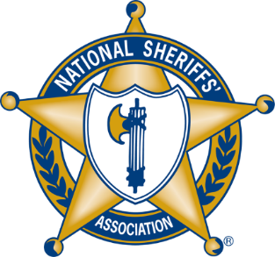

The National Sheriffs’ Association, the International Association of Chiefs of Police, and ASIS International Announce the Formation of the Annual International Public Law Enforcement/Private Security Partnership Day

Alexandria, VA - The National Sheriffs’ Association (NSA), the International Association of Chiefs of Police (IACP), and ASIS International (ASIS) are pleased to announce the initiation of the Public Law Enforcement/Private Security Partnership Day. Public-Private Partnership Day is a long-term collaborative effort between all three founding organizations and was approved by the boards of directors from all three partner organizations. It will occur on the fourth Thursday of April every year, with the inaugural Public-Private Partnership Day occurring on Thursday, April 25, 2024.

The mission of Public-Private Partnership Day is to foster and support the development of strong, robust, and enduring partnerships between the public safety community and the private security professions. An example of such a partnership is the New York City Police Department (NYPD) SHIELD program, a public-private partnership liaison program between the NYPD and New York City’s private and public sectors that has been instrumental in the fight against terrorism and criminal activity. The program has led to significant improvements in public safety and has become a model for similar programs globally.

Through these partnerships, leaders in the private security profession can collaborate with the leaders of the law enforcement and public safety community, and vice-versa. The result of this collaboration and knowledge sharing has significantly improved the level of safety, security and protection of people, property, and information. Building and maintaining strong public private partnership programs is essential in fighting the ever-increasing onslaught of all global criminal activity, from theft, to terrorism, to massive and crippling cyber-attacks.

Leaders from the IACP, the NSA, and ASIS are committed to making Public Private Partnership Day a meaningful day of recognition to highlight effective partnerships worldwide. The upcoming inaugural Partnership Day will forge a strong foundation and serve as an incentive for new and enhanced partnerships. For further information about making Public-Privat

About The National Sheriffs’ Association:
The National Sheriffs’ Association is one of the largest non-profit associations of law enforcement professionals in the United States, representing more than 3,000 elected sheriffs across the nation, and with a total membership of approximately 14,000 individuals. NSA is dedicated to raising the level of professionalism among sheriffs, their deputies, and others in the field of law enforcement, public safety, and criminal justice. Throughout its eighty-two-year history, NSA has also served as an information resource for all law enforcement, as well as local, state, and federal government agencies.

###

