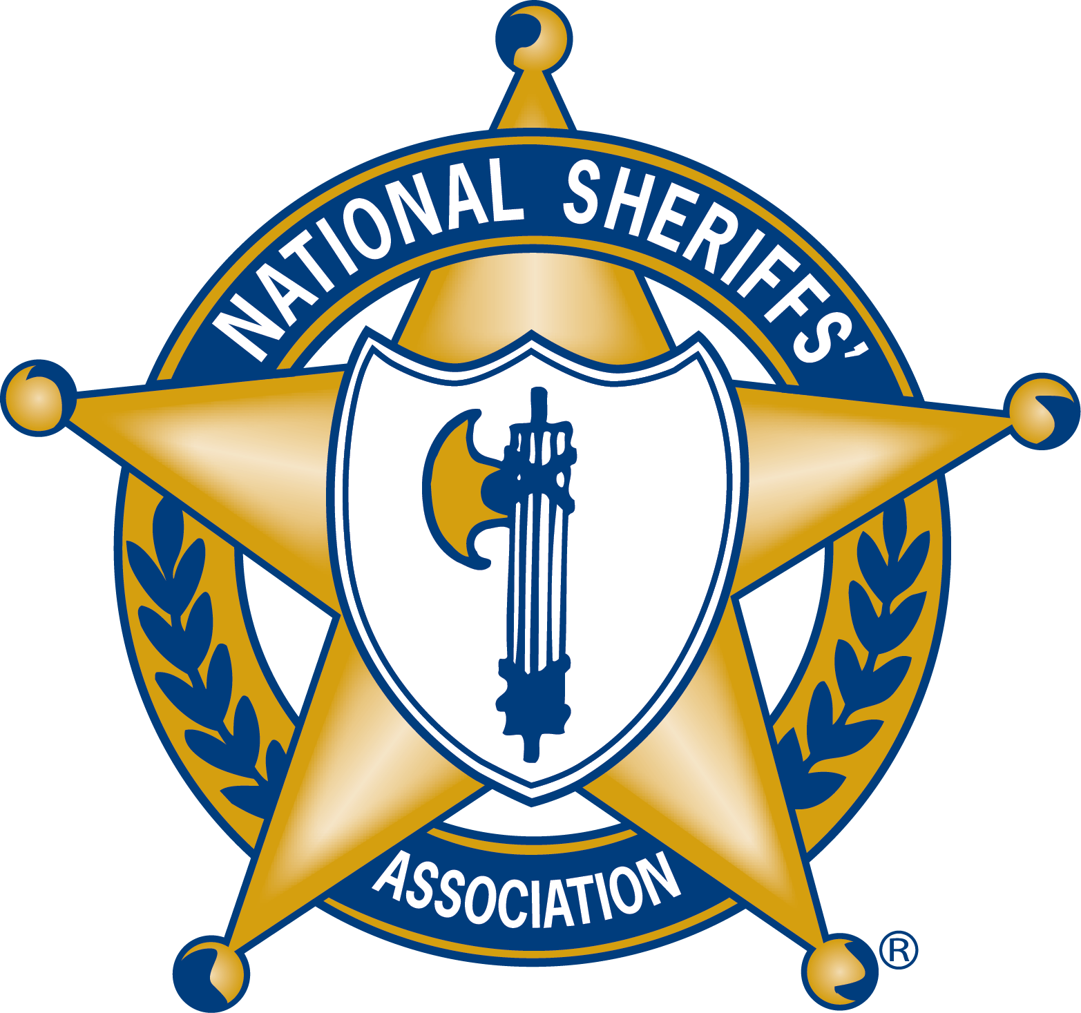
CHARLES “BUD” MEEKS

DEPUTY SHERIFF OF THE YEAR
FOR VALOR AWARD

NOMINEE INFORMATION

Name of Nominee

Address

City, State, Zip

Phone

E-Mail Address

Name of Nominee

Sheriffs’ Office of the Nominee

Title (Rank) of Nominee

Nominee’s Address

Nominee's Phone

Nominee's Cell Phone

Nominee’s E-Mail Address

AWARD APPLICATION

- In 300 words or less, please summarize why you feel this nominee should be selected as the NSA Deputy Sheriff of the Year for Valor?

- Please describe the meritorious activities and major accomplishments of the nominee.

- Please provide the member number the nominee’s Sherrif:
Contact erin@sheriffs.org if you need assistance with locating the number

SUBMISSION INSTRUCTIONS

To submit this nominee for consideration, please email the following items to jschmidt@sheriffs.org

- This nomination form.

- A copy of the nominee’s resume.

- A letter from the nominee’s Sheriff endorsing the application on office letterhead.

- Any additional documents to be considered.

Applications will be accepted until December 15, 2024 for
2025 award consideration.

